**THE TRIPLE MOON GODDESSES**

* 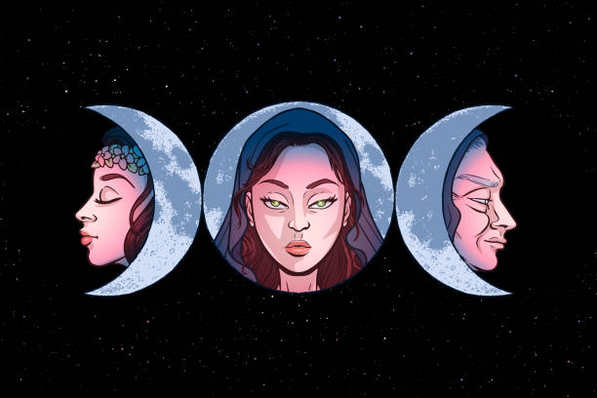You may have seen the print picture of the 3 girls in the moon, each one of them have their own meaning, the center is the mother (SELENE), the right side is the crone (HECATE), and the left side is the maiden (ARTEMIS). What have things that made by the mother, crone, and the maiden of the moon of goddesses, the mother (SELENE) represented the full moon, the mother symbolizes love, fertility, maturity, creativity, growth, and abundance. The crone (HECATE) represented by the waning moon, the crone symbolize time, wisdom, culmination n, creativity, knowledge, courage. The last is the maiden (ARTEMIS) represented by the waxing moon, the maiden symbolize youth, purity, pleasure, beginnings, wildness, freedom, innocence. This 3 goddesses are a famous and significant character in many world legends, spiritual traditions, and belief systems.

The triple moon goddesses teach us that life is cycle that is full of growth, happiness, sad, knowledge and changes in our life cycle, so much like the appearance of the moon. The moon inspires us that we need to continue our life even we are in a hardest part, just live with grace and understanding, and acknowledge the beauty and wisdom in our beloved world.